Setup minikube at your local and explore creating namespaces (Go through official documentation)

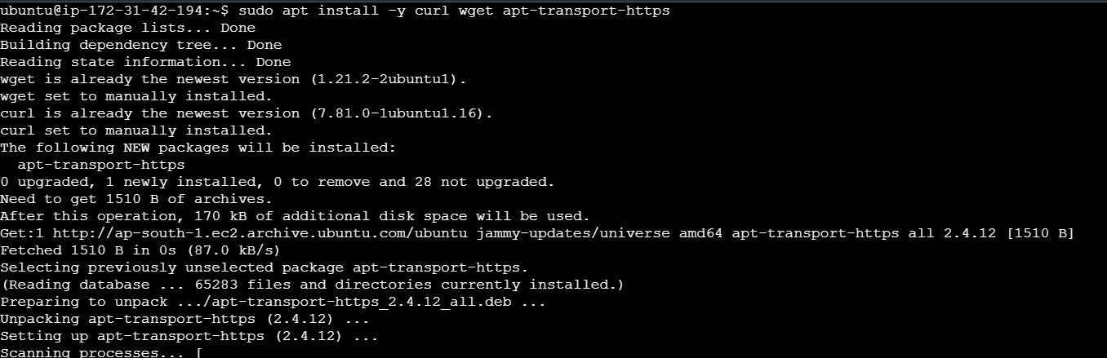

**Minikube can run a Kubernetes cluster either in a VM or locally via Docker. This guide demonstrates the Docker method.**

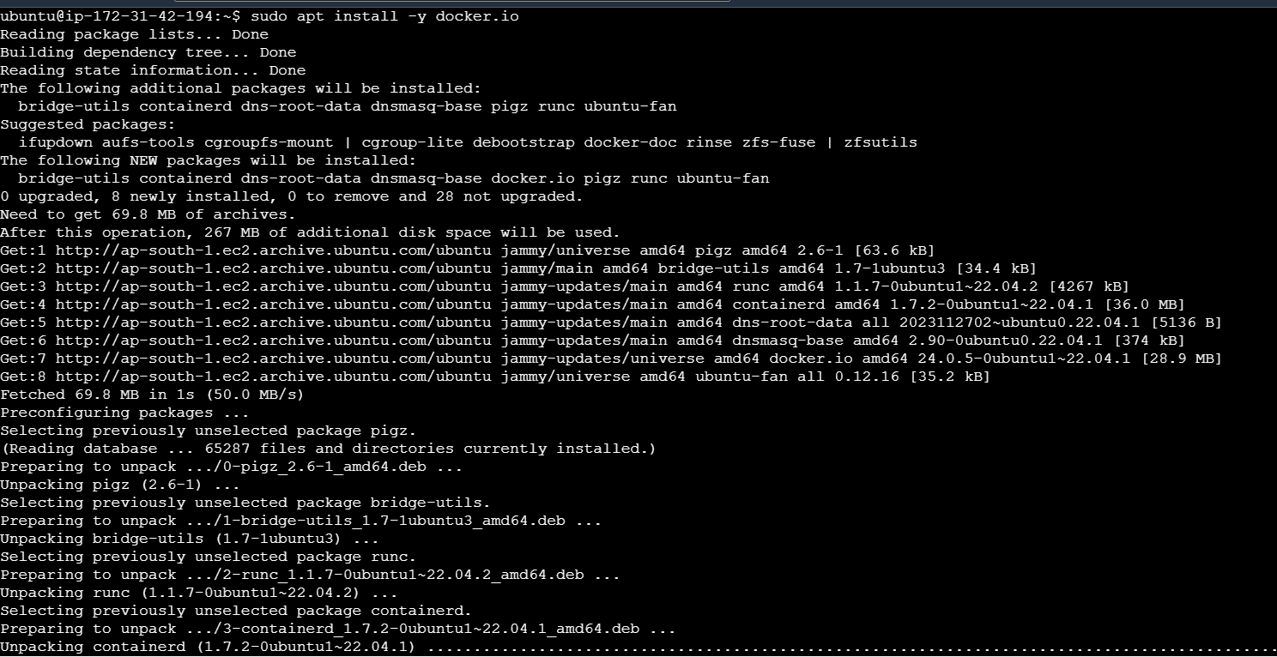

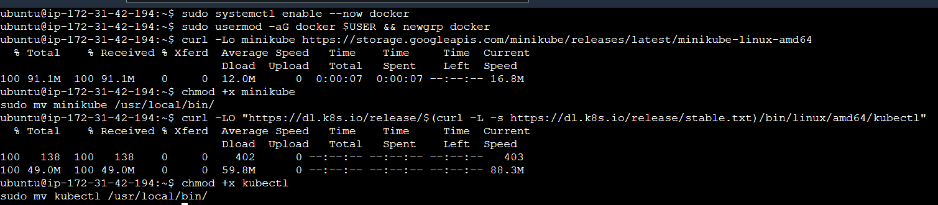

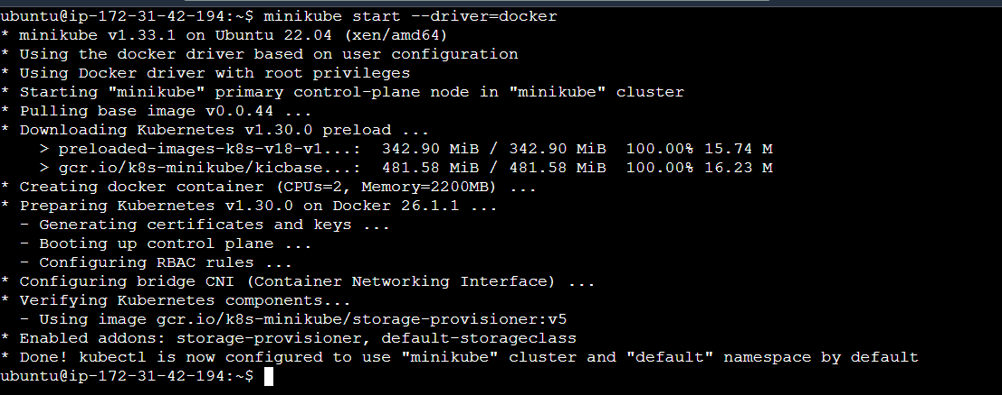

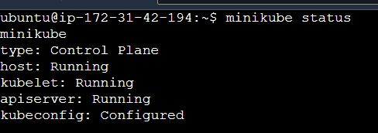

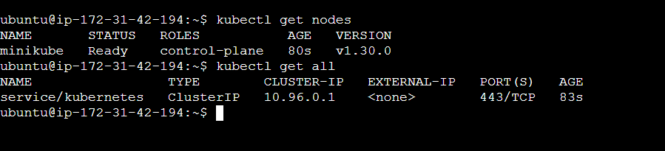

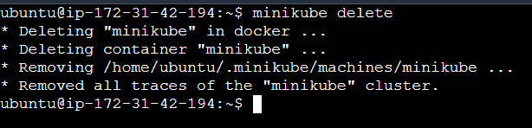

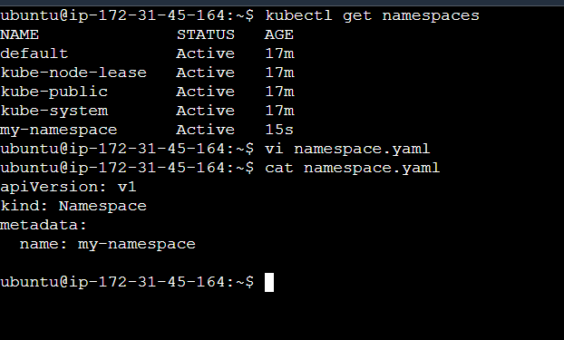

**Launch deployment in custom namespace [my-namespace]**

